**COURSE 3 MODULE 2 SOLUTIONS**

1)

SELECT CalMonth,AddrCatCode1,SUM(ExtCost) AS CostSum,SUM(Quantity) AS QuanSum

FROM Inventory_fact,date_dim,cust_vendor_dim

WHERE Inventory_fact.DateKey = date_dim.DateKey AND Inventory_fact.CustVendorKey = cust_vendor_dim.CustVendorKey AND Inventory_fact.TransTypeKey = 5 AND date_dim.CalYear = 2011

GROUP BY CUBE(CalMonth,AddrCatCode1)

ORDER BY CalMonth,AddrCatCode1;

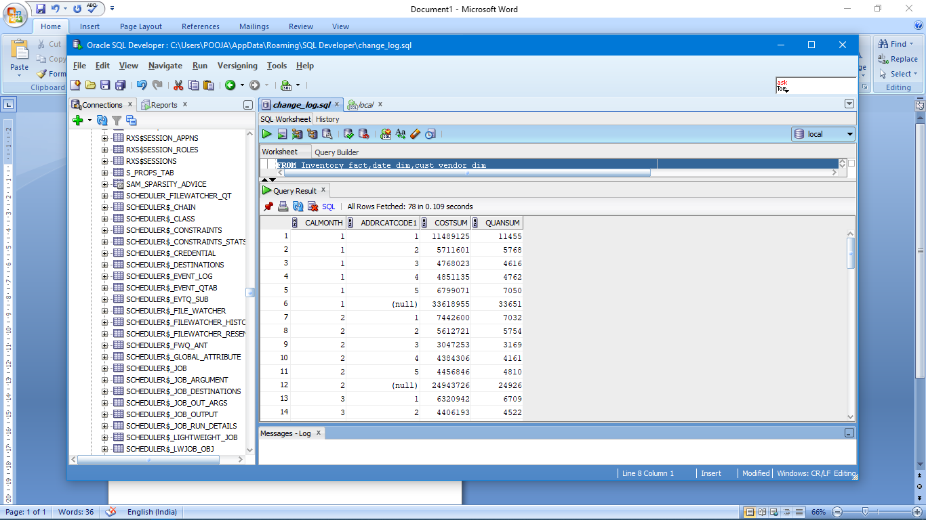

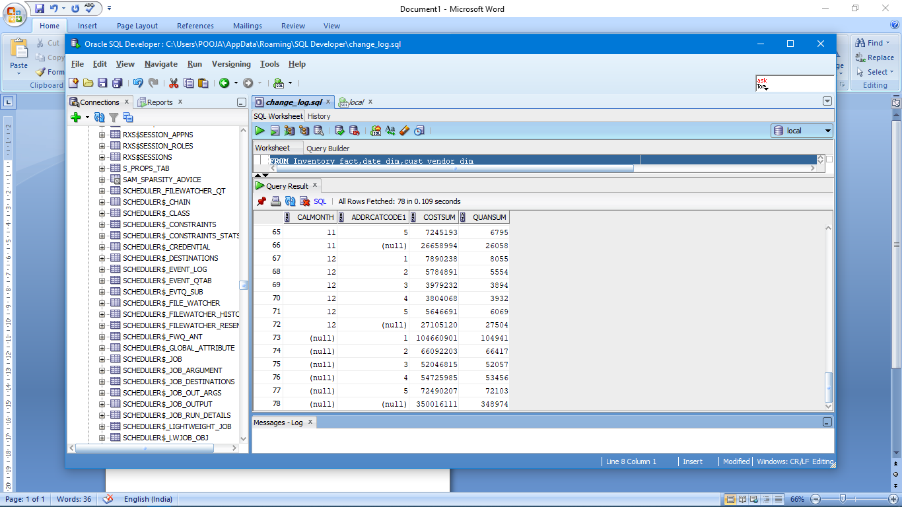

2)

SELECT CalQuarter,Zip,Name,SUM(ExtCost) AS CostSum,Count(*) AS INVCOUNT

FROM Inventory_fact,date_dim,cust_vendor_dim

WHERE Inventory_fact.DateKey = date_dim.DateKey AND Inventory_fact.CustVendorKey = cust_vendor_dim.CustVendorKey AND Inventory_fact.TransTypeKey = 5

AND (date_dim.CalYear = 2011 OR date_dim.CalYear = 2012)

GROUP BY GROUPING SETS( (CalQuarter,Zip,Name) ,(CalQuarter,Zip),(CalQuarter,Name) , (Name,Zip) ,CalQuarter,Zip,Name,())

ORDER BY CalQuarter,Zip,Name;

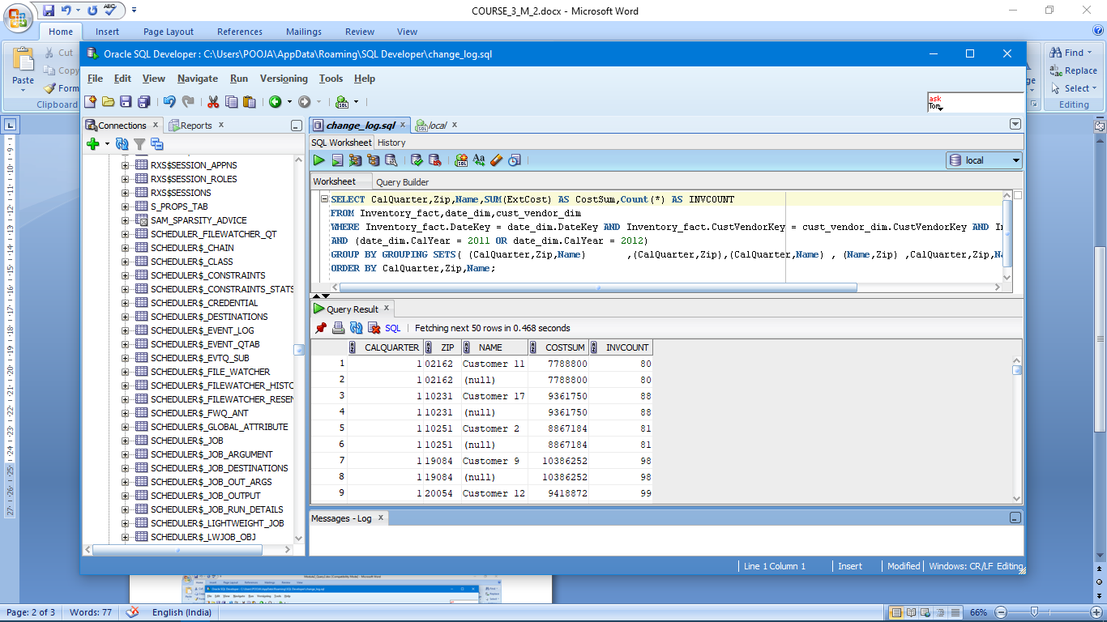

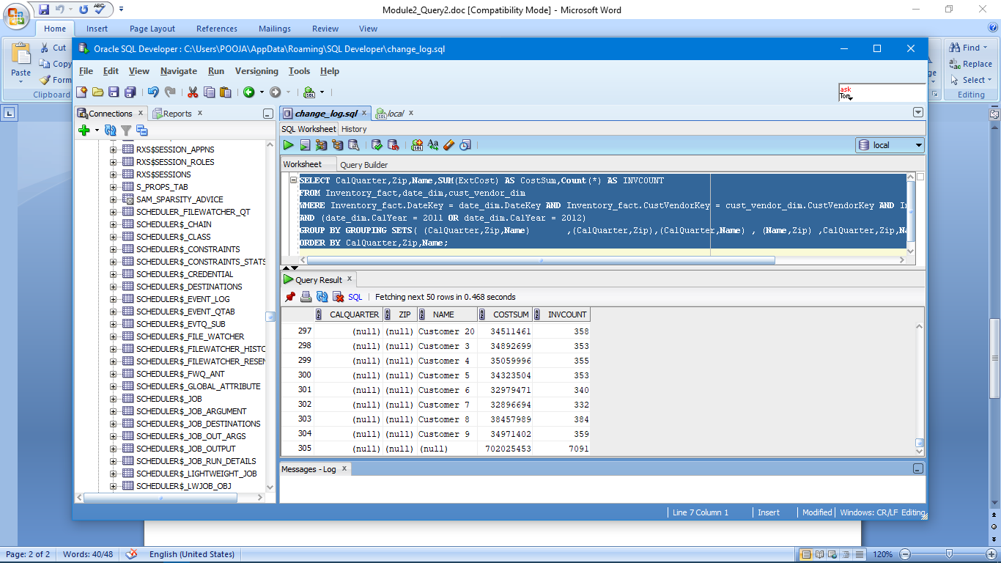

3)

SELECT CompanyName,BPName,SUM(ExtCost) AS COSTSUM,SUM(Quantity) AS QuanSum

FROM Inventory_fact,branch_plant_dim,company_dim

WHERE Inventory_fact.BRANCHPLANTKEY = branch_plant_dim.BRANCHPLANTKEY AND branch_plant_dim.COMPANYKEY = company_dim.COMPANYKEY AND Inventory_fact.TransTypeKey = 2

GROUP BY ROLLUP(CompanyName,BPName)

ORDER BY CompanyName,BPName;

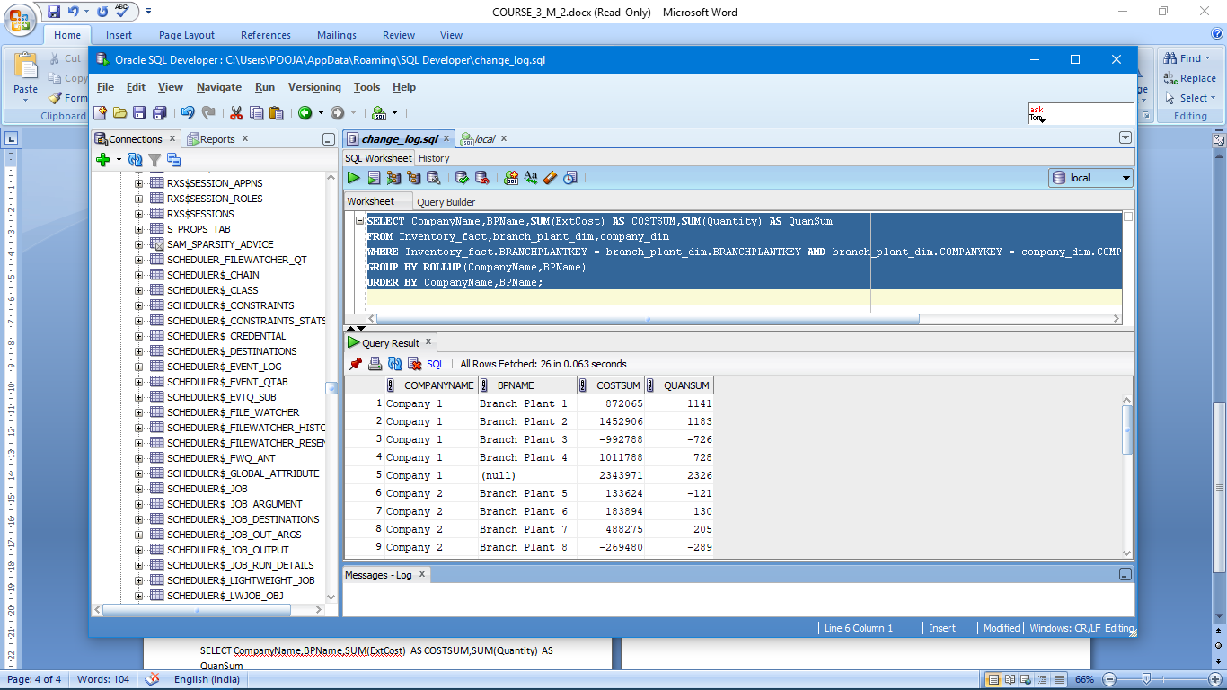

4)

SELECT TransDescription,CompanyName,BPName,SUM(ExtCost) AS COSTSUM,Count(*) AS INVCOUNT

FROM Inventory_fact,trans_type_dim,branch_plant_dim,company_dim

WHERE Inventory_fact.BRANCHPLANTKEY = branch_plant_dim.BRANCHPLANTKEY AND branch_plant_dim.COMPANYKEY = company_dim.COMPANYKEY

AND Inventory_fact.TRANSTYPEKEY = trans_type_dim.TRANSTYPEKEY

GROUP BY GROUPING SETS ( (TransDescription,CompanyName,BPName),(TransDescription,CompanyName), TransDescription,())

ORDER BY TransDescription,CompanyName,BPName;

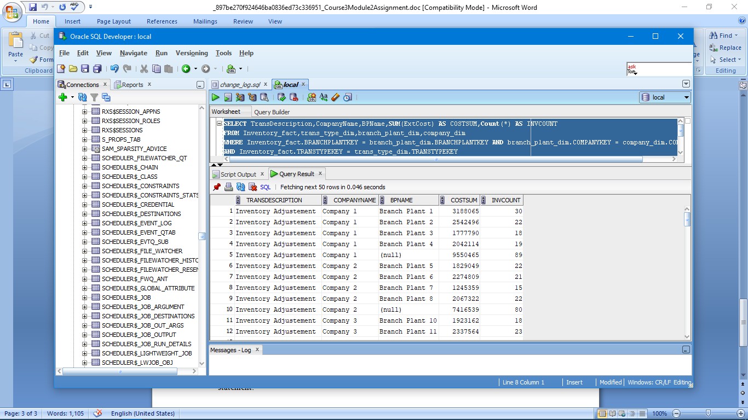

5)

SELECT CalYear,CalQuarter,Name,SUM(ExtCost) AS CUSTSUM,Count(*) AS INVCOUNT

FROM Inventory_fact,date_dim,cust_vendor_dim

WHERE Inventory_fact.DateKey = date_dim.DateKey AND Inventory_fact.CustVendorKey = cust_vendor_dim.CustVendorKey AND Inventory_fact.TransTypeKey = 5

AND (date_dim.CalYear = 2011 or date_dim.CalYear = 2012)

GROUP BY Name,ROLLUP(CalYear,CalQuarter)

ORDER BY CalYear,CalQuarter,Name;

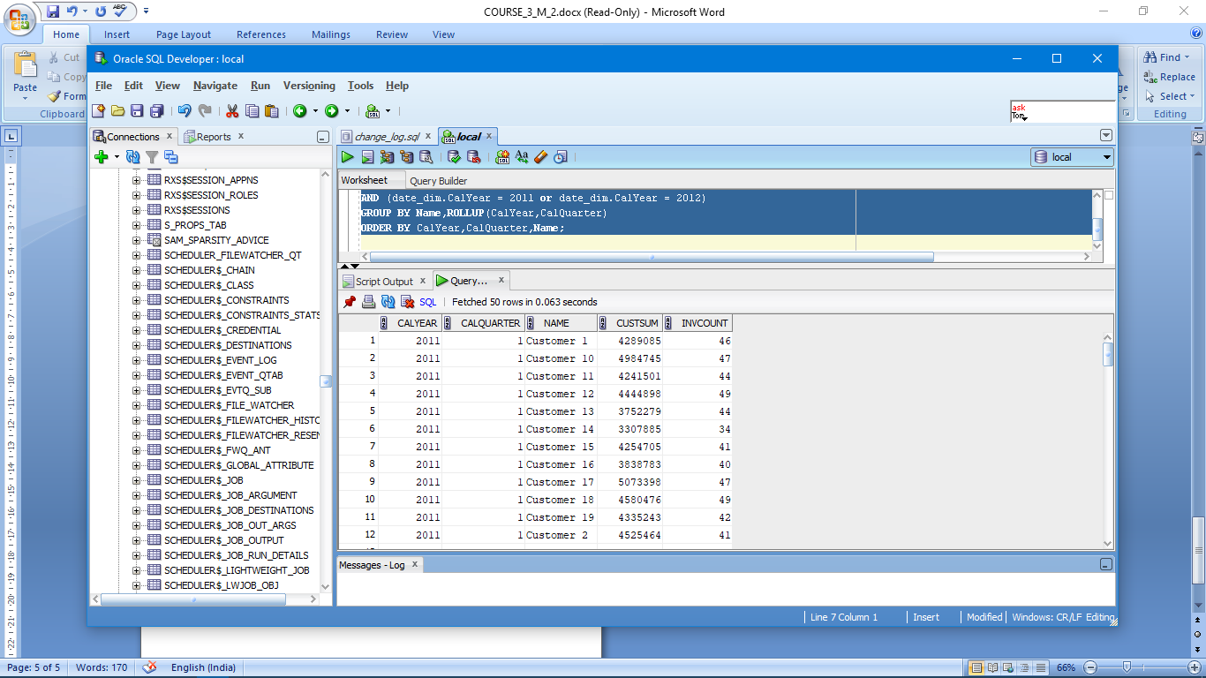

6)

SELECT CalMonth,AddrCatCode1,SUM(ExtCost) AS CostSum,SUM(Quantity) AS QuanSum

FROM Inventory_fact,date_dim,cust_vendor_dim

WHERE Inventory_fact.DateKey = date_dim.DateKey AND Inventory_fact.CustVendorKey = cust_vendor_dim.CustVendorKey AND Inventory_fact.TransTypeKey = 5

AND date_dim.CalYear = 2011

GROUP BY CalMonth,AddrCatCode1

UNION

SELECT CalMonth,NULL,SUM(ExtCost) AS CostSum,SUM(Quantity) AS QuanSum

FROM Inventory_fact,date_dim,cust_vendor_dim

WHERE Inventory_fact.DateKey = date_dim.DateKey AND Inventory_fact.CustVendorKey = cust_vendor_dim.CustVendorKey AND Inventory_fact.TransTypeKey = 5

AND date_dim.CalYear = 2011

GROUP BY CalMonth

UNION

SELECT NULL,AddrCatCode1,SUM(ExtCost) AS CostSum,SUM(Quantity) AS QuanSum

FROM Inventory_fact,date_dim,cust_vendor_dim

WHERE Inventory_fact.DateKey = date_dim.DateKey AND Inventory_fact.CustVendorKey = cust_vendor_dim.CustVendorKey AND Inventory_fact.TransTypeKey = 5

AND date_dim.CalYear = 2011

GROUP BY AddrCatCode1

UNION

SELECT NULL,NULL,SUM(ExtCost) AS CostSum,SUM(Quantity) AS QuanSum

FROM Inventory_fact,date_dim,cust_vendor_dim

WHERE Inventory_fact.DateKey = date_dim.DateKey AND Inventory_fact.CustVendorKey = cust_vendor_dim.CustVendorKey AND Inventory_fact.TransTypeKey = 5

AND date_dim.CalYear = 2011

ORDER BY 1, 2;

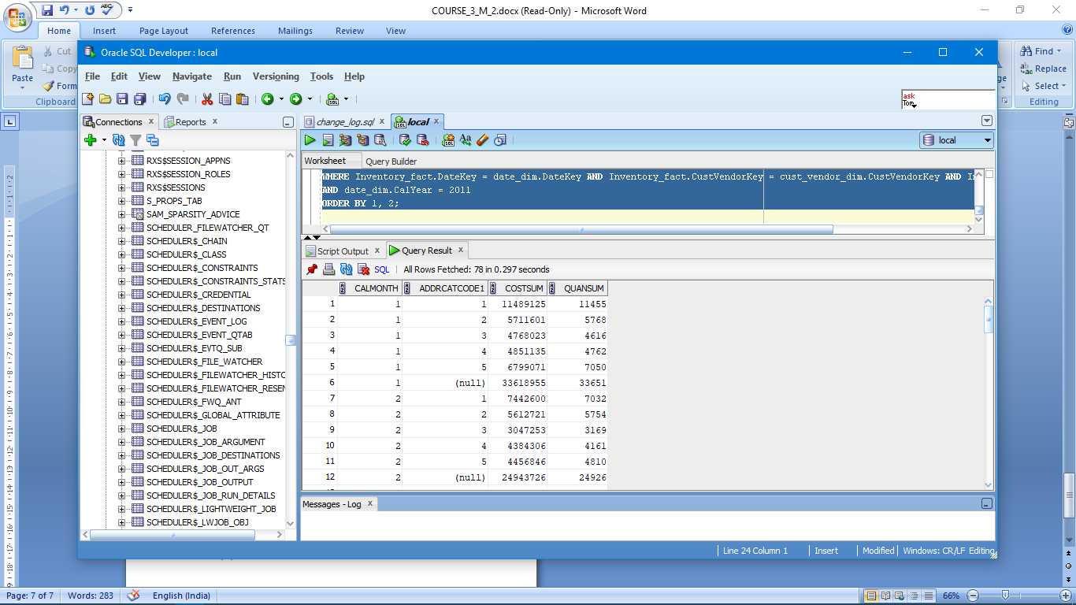

7)

SELECT CompanyName,BPName,SUM(ExtCost) AS COSTSUM,SUM(Quantity) AS QuanSum

FROM Inventory_fact,branch_plant_dim,company_dim

WHERE Inventory_fact.BRANCHPLANTKEY = branch_plant_dim.BRANCHPLANTKEY AND branch_plant_dim.COMPANYKEY = company_dim.COMPANYKEY AND Inventory_fact.TransTypeKey = 2

GROUP BY CompanyName,BPName

UNION

SELECT CompanyName,NULL,SUM(ExtCost) AS COSTSUM,SUM(Quantity) AS QuanSum

FROM Inventory_fact,branch_plant_dim,company_dim

WHERE Inventory_fact.BRANCHPLANTKEY = branch_plant_dim.BRANCHPLANTKEY AND branch_plant_dim.COMPANYKEY = company_dim.COMPANYKEY AND Inventory_fact.TransTypeKey = 2

GROUP BY CompanyName

UNION

SELECT NULL,NULL,SUM(ExtCost) AS COSTSUM,SUM(Quantity) AS QuanSum

FROM Inventory_fact,branch_plant_dim,company_dim

WHERE Inventory_fact.BRANCHPLANTKEY = branch_plant_dim.BRANCHPLANTKEY AND branch_plant_dim.COMPANYKEY = company_dim.COMPANYKEY AND Inventory_fact.TransTypeKey = 2

ORDER BY 1,2;

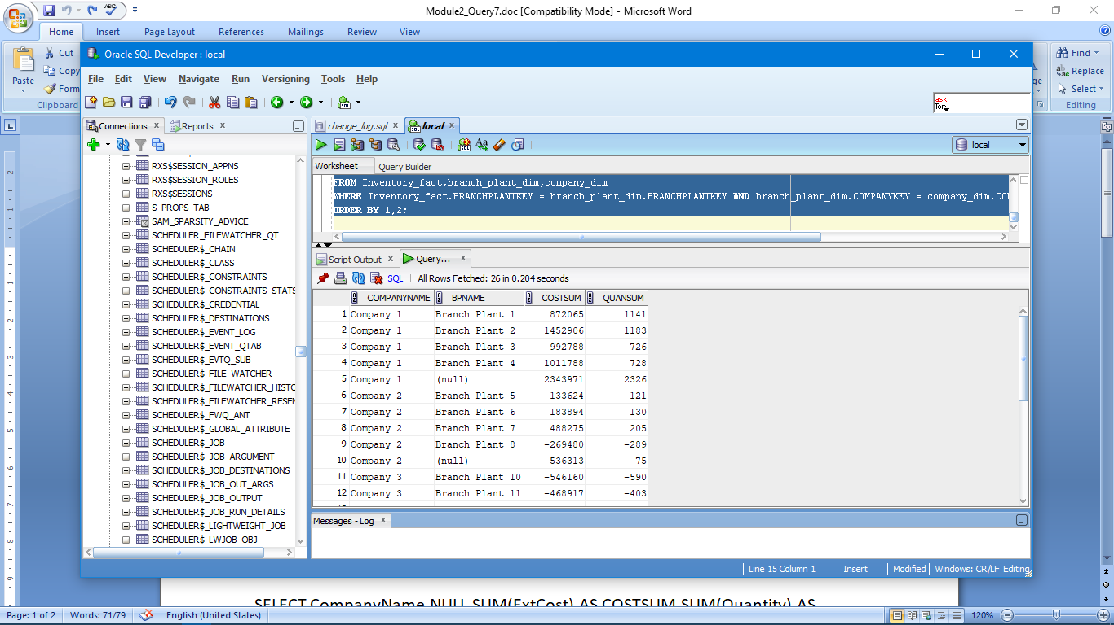

8)

SELECT CalYear,CalQuarter,Name,SUM(ExtCost) AS CUSTSUM,Count(*) AS INVCOUNT

FROM Inventory_fact,date_dim,cust_vendor_dim

WHERE Inventory_fact.DateKey = date_dim.DateKey AND Inventory_fact.CustVendorKey = cust_vendor_dim.CustVendorKey AND Inventory_fact.TransTypeKey = 5

AND (date_dim.CalYear = 2011 or date_dim.CalYear = 2012)

GROUP BY CUBE(Name,(CalYear,CalQuarter))

ORDER BY CalYear,CalQuarter,Name;

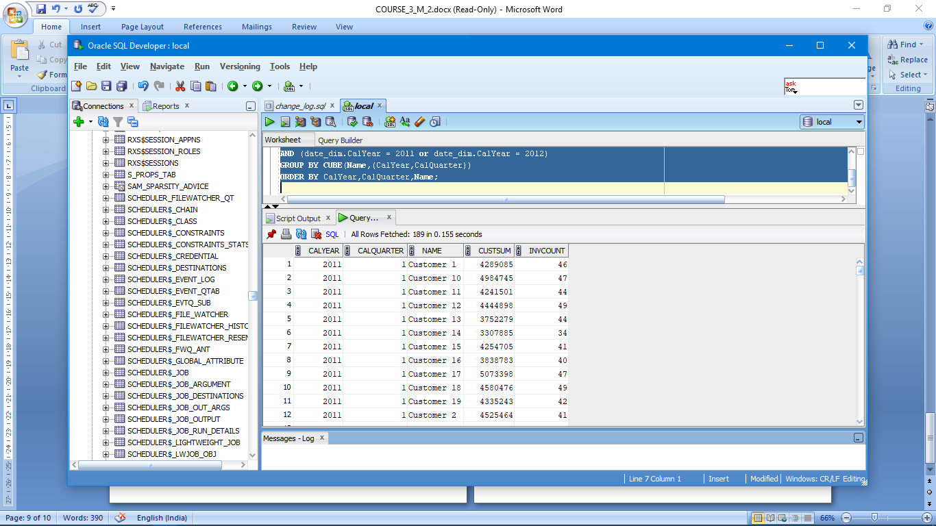

9)

SELECT CalMonth,AddrCatCode1,SUM(ExtCost) AS CostSum,SUM(Quantity) AS QuanSum, GROUPING_ID(CalMonth,AddrCatCode1) AS GROUP_NUMBER

FROM Inventory_fact,date_dim,cust_vendor_dim

WHERE Inventory_fact.DateKey = date_dim.DateKey AND Inventory_fact.CustVendorKey = cust_vendor_dim.CustVendorKey AND Inventory_fact.TransTypeKey = 5

AND date_dim.CalYear = 2011

GROUP BY CUBE(CalMonth,AddrCatCode1)

ORDER BY CalMonth,AddrCatCode1;

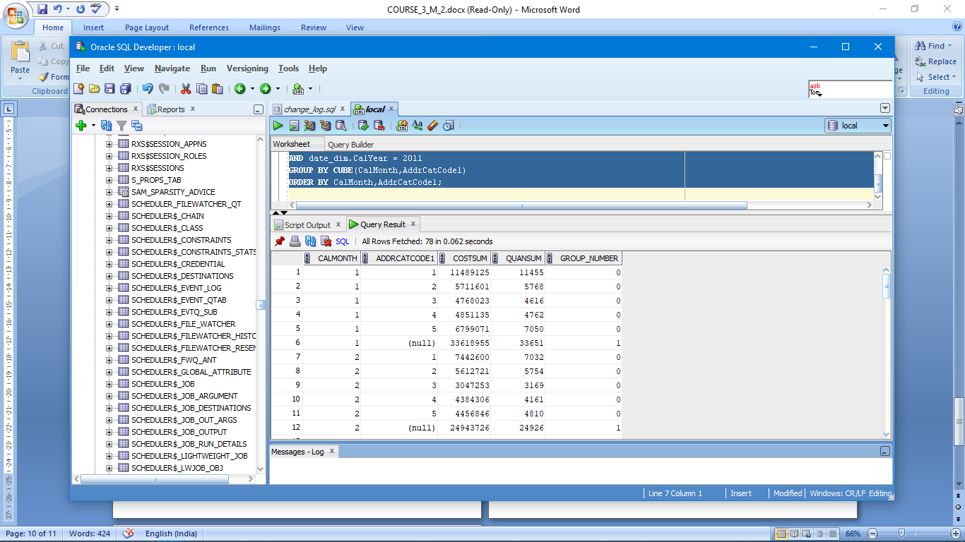

10)

SELECT CalYear,CalQuarter,Name,SUM(ExtCost) AS CUSTSUM,Count(*) AS INVCOUNT

FROM Inventory_fact,date_dim,cust_vendor_dim

WHERE Inventory_fact.DateKey = date_dim.DateKey AND Inventory_fact.CustVendorKey = cust_vendor_dim.CustVendorKey AND Inventory_fact.TransTypeKey = 5

AND (date_dim.CalYear = 2011 or date_dim.CalYear = 2012)

GROUP BY GROUPING SETS(Name,ROLLUP(CalYear,CalQuarter))

ORDER BY CalYear,CalQuarter,Name;

